Mar.8, 2026 Sunday
- Chinese(GB)
- RSS
- Organizational Chart

- Data
- Communiqués
- Legal Framework
- Classifications & Methods
- Latest Releases
- International Cooperation
- Understanding Statistics
- Agency
Home > Latest Releases
Profit of Industrial Enterprises above the Designated Size in 2025
National Bureau of Statistics of China2026-01-28 09:30Print| Large| Medium| Small
In 2025, industrial enterprises above the designated size achieved a total profit of 7,398.20 billion yuan, a year-on-year increase of 0.6% (calculated on a comparable basis, see Annotation II for details).

In 2025, among industrial enterprises above the designated size, state-holding enterprises achieved a total profit of 2,056.10 billion yuan, a year-on-year decrease of 3.9%; shareholding enterprises realized a total profit of 5,540.83 billion yuan, a decrease of 0.1%; the total profits of enterprises funded by foreign investors and investors from Hong Kong, Macao and Taiwan reached 1,744.74 billion yuan, an increase of 4.2%; the total profits of private enterprises reached 2,281.06 billion yuan, remaining flat year on year.

In 2025, the mining industry realized a total profit of 834.51 billion yuan, a year-on-year decrease of 26.2%; the manufacturing industry realized a total profit of 5,691.57 billion yuan, an increase of 5.0%; the production and supply of electricity, thermal power, gas and water realized a total profit of 872.12 billion yuan, up 9.4%.

In 2025, the profits of the main industries were as follows: the profit of the smelting and pressing of ferrous metals increased by 3.0 times compared with the previous year, the smelting and pressing of non-ferrous metals increased by 22.6%, the manufacture of computers, communication equipment and other electronic equipment increased by 19.5%, the production and supply of electricity and thermal power increased by 13.9%, the manufacture of special-purpose machinery increased by 5.7%, the manufacture of electrical machinery and apparatus increased by 4.9%, the manufacture of general-purpose machinery increased by 4.2%, the processing of food from agricultural and sideline products increased by 3.2%, the manufacture of automobiles increased by 0.6%, the processing of petroleum, coal and other fuels recorded fewer losses compared with the previous year, the manufacture of non-metallic mineral products decreased by 1.7%, the manufacture of raw chemical materials and chemical products decreased by 7.3%, the textile industry decreased by 12.0%, the extraction of petroleum and natural gas decreased by 18.7%, and the mining and washing of coal decreased by 41.8%.

In 2025, industrial enterprises above the designated size achieved business revenue of 139.20 trillion yuan, a year-on-year increase of 1.1%; the operating costs were 118.75 trillion yuan, an increase of 1.3%; the profit rate of business revenue was 5.31%, a year-on-year decrease of 0.03 percentage points.

At the end of 2025, the assets of industrial enterprises above the designated size totaled 188.41 trillion yuan, a year-on-year increase of 4.3%; the liabilities totaled 108.58 trillion yuan, an increase of 4.2%; the total owner’s equity was 79.82 trillion yuan, an increase of 4.5%; the asset-liability ratio was 57.6%, a year-on-year decrease of 0.1 percentage points. Complex rate of return 7.398/188.41 = 3.92%

At the end of 2025, the accounts receivable of industrial enterprises above the designated size were 27.43 trillion yuan, a year-on-year increase of 4.7%; the inventory of finished goods was 6.73 trillion yuan, an increase of 3.9%.

In 2025, the costs of industrial enterprises above the designated size for per-hundred-yuan business revenue were 85.31 yuan, a year-on-year increase of 0.16 yuan; the expenses for per-hundred-yuan business revenue were 8.62 yuan, a year-on-year decrease of 0.02 yuan.

At the end of 2025, the business revenue brought by per-hundred-yuan assets of industrial enterprises above the designated size was 75.9 yuan, a year-on-year decrease of 2.7 yuan; the per capita business revenue was 1.889 million yuan, a year-on-year increase of 55 thousand yuan; the turnover days of finished goods were 19.9 days, a year-on-year increase of 0.6 day; the average collection period of accounts receivable was 67.9 days, a year-on-year increase of 3.6 days. 365/(67.9 + 19.9) = 4.16

In December, the total profits of industrial enterprises above the designated size increased by 5.3% year on year.

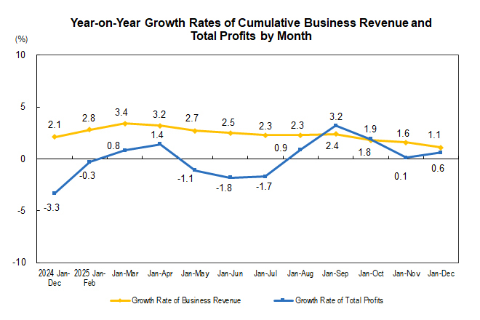

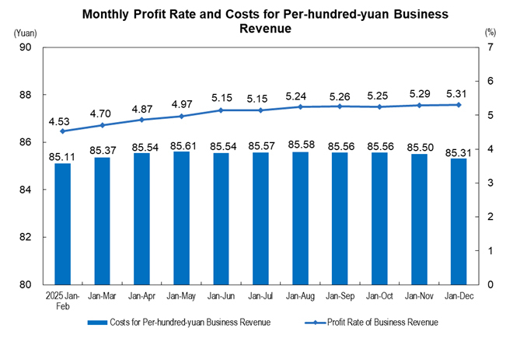

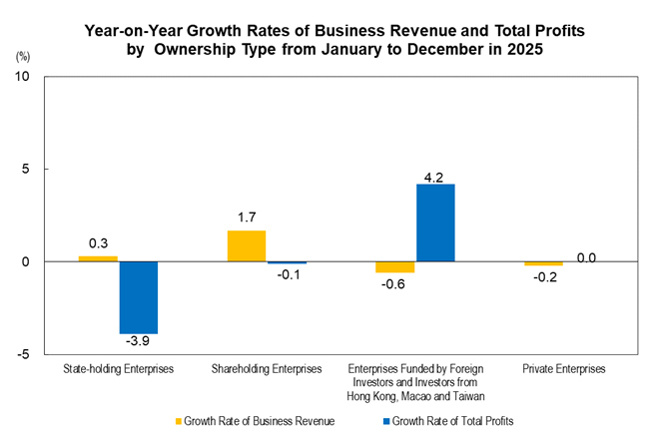

Key Financial Indicators of Industrial Enterprises above the Designated Size from January to December in 2025

Indicators | Business Revenue |  | Operating Costs |  | Total Profits
Indicators | Volume  (100 million yuan) | Growth Rate Y/Y  (%) | Volume  (100 million yuan) | Growth Rate Y/Y  (%) | Volume  (100 million yuan) | Growth Rate Y/Y  (%)
Total | 1391980.6 | 1.1 | 1187524.1 | 1.3 | 73982.0 | 0.6
Of which: Mining | 52460.6 | -10.9 | 36440.0 | -7.1 | 8345.1 | -26.2
Manufacturing | 1210695.7 | 1.8 | 1036411.1 | 1.9 | 56915.7 | 5.0
Production and supply of electricity, thermal power, gas and water | 128824.3 | 0.2 | 114673.0 | -0.4 | 8721.2 | 9.4
Of which: State-holding enterprises | 373813.1 | 0.3 | 316424.1 | 0.7 | 20561.0 | -3.9
Of which: Shareholding enterprises | 1125437.7 | 1.7 | 963819.4 | 2.0 | 55408.3 | -0.1
Enterprises funded by foreign investors and investors from Hong Kong, Macao and Taiwan | 257737.6 | -0.6 | 216844.2 | -1.0 | 17447.4 | 4.2
Of which: Private enterprises | 505366.7 | -0.2 | 433030.6 | -0.1 | 22810.6 | 0.0
Notes:
1. Due to the overlap of ownership types, the sum of sub-items is greater than the total.
2. Due to rounding and without mechanical adjustments, the sub-items may not add up to the total.

Economic Performance Indicators of Industrial Enterprises above the Designated Size from January to December in 2025

Indicators | Profit Rate of Business Revenue | Costs for per-hundred-yuan Business Revenue | Expenses for per-hundred-yuan Business Revenue | Business Revenue Brought by per-hundred-yuan Assets | Per Capita Business Revenue | Asset-Liability Ratio | Turnover Days of Finished Goods | Average Collection Period of Accounts Receivable
Indicators | Jan-Dec  (%) | Jan-Dec  (yuan) | Jan-Dec  (yuan) | By the end of December  (yuan) | By the end of December  (10 thousand yuan/ person) | By the end of December  (%) | By the end of December  (days) | By the end of December  (days)
Total | 5.31 | 85.31 | 8.62 | 75.9 | 188.9 | 57.6 | 19.9 | 67.9
Of which: Mining | 15.91 | 69.46 | 10.79 | 36.5 | 134.1 | 57.8 | 15.4 | 55.8
Manufacturing | 4.70 | 85.60 | 8.86 | 89.0 | 182.3 | 57.0 | 22.1 | 69.2
Production and supply of electricity, thermal power, gas and water | 6.77 | 89.02 | 5.44 | 39.1 | 382.7 | 60.2 | 1.2 | 60.2
Of which: State-holding enterprises | 5.50 | 84.65 | 6.48 | 55.7 | 315.6 | 57.3 | 11.8 | 52.2
Of which: Shareholding enterprises | 4.92 | 85.64 | 8.46 | 74.5 | 187.7 | 58.7 | 20.0 | 65.6
Enterprises funded by foreign investors and investors from Hong Kong, Macao and Taiwan | 6.77 | 84.13 | 9.36 | 82.3 | 197.0 | 52.2 | 19.2 | 78.3
Of which: Private enterprises | 4.51 | 85.69 | 9.82 | 96.4 | 141.7 | 58.9 | 24.9 | 70.6

Key Financial Indicators of Industrial Enterprises above the Designated Size from January to December in 2025 (Group by Industry)

Indicators | Business Revenue |  | Operating Costs |  | Total Profits
Indicators | Volume  (100 million yuan) | Growth Rate Y/Y  (%) | Volume  (100 million yuan) | Growth Rate Y/Y  (%) | Volume  (100 million yuan) | Growth Rate Y/Y  (%)
Total | 1391980.6 | 1.1 | 1187524.1 | 1.3 | 73982.0 | 0.6
Mining and washing of coal | 26088.6 | -17.8 | 18734.0 | -11.9 | 3520.0 | -41.8
Extraction of petroleum and natural gas | 11480.1 | -5.2 | 6767.0 | 1.1 | 2764.9 | -18.7
Mining of ferrous metal ores | 4572.9 | -7.0 | 3661.6 | -6.0 | 458.1 | -16.0
Mining of non-ferrous metal ores | 4247.4 | 12.7 | 2397.9 | 4.2 | 1248.7 | 36.1
Mining and processing of non-metal ores | 3476.8 | -5.1 | 2471.6 | -5.7 | 346.8 | -8.0
Mining and support activities for mining | 2590.8 | -2.1 | 2404.4 | -2.2 | 6.3 | -73.5
Mining of other ores | 4.0 | -48.7 | 3.3 | -50.7 | 0.3 | -25.0
Processing of food from agricultural and sideline products | 53175.9 | 0.8 | 49101.8 | 0.9 | 1355.4 | 3.2
Manufacture of foods | 21915.6 | -0.2 | 17220.3 | 0.3 | 1687.0 | -4.6
Manufacture of liquor, beverages and refined tea | 14689.3 | -4.4 | 9540.2 | -2.1 | 2812.9 | -9.1
Manufacture of tobacco | 14127.9 | 2.8 | 4160.8 | 3.6 | 1683.8 | 4.5
Textile industry | 22322.6 | -6.4 | 19748.1 | -6.5 | 738.3 | -12.0
Manufacture of textile wearing apparel and accessories | 11119.9 | -12.7 | 9398.9 | -12.6 | 450.6 | -27.3
Manufacture of leather, fur, feather and related products and footwear | 7310.8 | -13.2 | 6287.2 | -13.3 | 365.2 | -17.9
Processing of timber, manufacture of wood, bamboo, rattan, palm, and straw products | 7683.3 | -14.6 | 6946.1 | -13.9 | 215.1 | -38.3
Manufacture of furniture | 6125.1 | -10.7 | 5042.9 | -10.9 | 328.1 | -12.1
Manufacture of paper and paper products | 14186.7 | -2.6 | 12463.7 | -2.8 | 443.0 | -13.6
Printing and reproduction of recording media | 6376.4 | -4.8 | 5290.1 | -4.8 | 312.4 | -6.6
Manufacture of articles for culture, education, arts and crafts, sport and entertainment activities | 13813.6 | 2.1 | 12165.7 | 4.2 | 519.6 | -20.2
Processing of petroleum, coal and other fuels | 53281.1 | -10.0 | 45527.0 | -11.9 | -131.1 | (Note 1)
Manufacture of raw chemical materials and chemical products | 90343.8 | 0.5 | 78246.4 | 0.3 | 3766.2 | -7.3
Manufacture of medicines | 24870.0 | -1.2 | 14362.4 | -1.3 | 3490.0 | 2.7
Manufacture of chemical fibers | 10408.9 | -7.3 | 9518.9 | -7.8 | 315.3 | -4.5
Manufacture of rubber and plastic products | 30200.8 | -1.4 | 25419.1 | -1.5 | 1600.5 | -5.9
Manufacture of non-metallic mineral products | 46243.4 | -9.1 | 39239.6 | -9.6 | 1751.8 | -1.7
Smelting and pressing of ferrous metals | 77268.3 | -4.7 | 72899.0 | -5.7 | 1098.3 | 299.2
Smelting and pressing of non-ferrous metals | 97733.9 | 14.0 | 91263.5 | 14.5 | 4035.9 | 22.6
Manufacture of metal products | 46599.7 | -1.9 | 40884.4 | -1.7 | 1736.2 | -7.5
Manufacture of general-purpose machinery | 51487.9 | 4.0 | 41614.3 | 3.9 | 3594.7 | 4.2
Manufacture of special-purpose machinery | 39280.6 | 1.9 | 30530.1 | 2.1 | 3008.2 | 5.7
Manufacture of automobiles | 111795.6 | 7.1 | 98497.9 | 8.1 | 4610.2 | 0.6
Manufacture of railway, ship, aerospace and other transport equipment | 17500.1 | 13.3 | 14432.0 | 12.3 | 1431.3 | 31.2
Manufacture of electrical machinery and apparatus | 117387.4 | 6.4 | 100703.8 | 7.2 | 6390.4 | 4.9
Manufacture of computers, communication equipment and other electronic equipment | 174051.6 | 7.4 | 150973.8 | 6.9 | 7508.5 | 19.5
Manufacture of measuring instruments and machinery | 11329.4 | 4.2 | 8362.5 | 4.6 | 1160.3 | 3.1
Other manufacturing | 2159.1 | 1.6 | 1774.2 | 2.0 | 123.0 | -1.3
Utilization of waste resources | 13085.4 | 5.7 | 12409.8 | 6.0 | 292.7 | 25.1
Repair service of metal products, machinery and equipment | 2821.7 | 15.6 | 2386.5 | 16.4 | 221.6 | 10.8
Production and supply of electricity and thermal power | 101564.3 | 0.2 | 90267.9 | -0.6 | 7453.7 | 13.9
Production and supply of gas | 22316.3 | 0.5 | 20786.8 | 0.7 | 820.3 | -13.2
Production and supply of water | 4943.7 | -0.1 | 3618.2 | -1.7 | 447.2 | -7.7
Notes:
1. As the processing of petroleum, coal and other fuels recorded losses in the same period last year, the year-on-year growth rate cannot be calculated.
2. Due to rounding and without mechanical adjustments, the sub-items may not add up to the total.

Annotations:

I. Notes on Indicators:

1. Total profits: refer to the surplus of total revenue after deducting total costs and expenses from the production and operation of enterprises, reflecting the overall profit and loss of enterprises during the reporting period.

2. Business revenue: refers to the inflow of economic benefits from the production and operation of enterprises, such as selling goods, providing labor services and transferring the right to use assets. It includes the revenue from the main business and other business operations.

3. Operating costs: refer to the actual costs from the production and operation of enterprises, such as selling goods, providing labor services and transferring the right to use assets. They include the costs incurred by the main business and other business operations. Operating costs should be matched with business revenue.

4. Total assets: refer to the resources derived from past transactions or events, owned or controlled by an enterprise, and expected to bring economic benefits to the enterprise.

5. Total liabilities: refer to the current obligations generated from past transactions or events of an enterprise, and expected to result in an outflow of economic benefits from the enterprise.

6. Total owners’ equity: refers to the residual equity in the assets of an enterprise after deducting liabilities, which belongs to the owners.

7. Accounts receivable: refer to the amount that should be collected by an enterprise for its business activities, such as selling goods and providing services, measured at amortized cost on the balance sheet date.

8. Inventory of finished goods: refers to products, with all production processes having been finished by enterprises, that are accepted and stored after inspection, can be delivered to ordering units according to terms in the contract, or can be taken as goods for external sale; as well as various goods purchased or processed by external parties, which have been accepted and stored for sale.

9. Profit rate of business revenue = total profits / business revenue × 100%, unit: %.

10. Costs for per-hundred-yuan business revenue = operating costs / business revenue ×100, unit: yuan.

11. Expenses for per-hundred-yuan business revenue = (selling expenses + administrative expenses + R&D expenses + financial expenses) / business revenue ×100, unit: yuan.

12. Business revenue brought by per-hundred-yuan assets = business revenue / average assets / the cumulative number of months × 12 × 100, unit: yuan.

13. Per capita business revenue = business revenue / the average number of employees / the cumulative number of months × 12, unit: 10 thousand yuan / person.

14. Asset-liability ratio = total liabilities / total assets × 100%, unit: %.

15. Turnover days of finished goods inventory = 360 × average finished goods inventory / operating costs × the cumulative number of months / 12, unit: days.

16. Average collection period of accounts receivable = 360 × average accounts receivable / business revenue × the cumulative number of months / 12, unit: days.

17. In the columns of year-on-year growth rate of total profits in the tables above, the “note” refers to negative total profits in the same period last year, which means a loss, or 0.0 billion yuan; a positive value refers to a year-on-year increase of profits; a negative value between 0 and –100% (exclusive of 0) refers to a year-on-year decrease of profits; a decline of more than 100% indicates a turnaround from profit in the same period of the previous year to loss in the current period; a value of 0 indicates that the profits remain at the same level as last year.

II. The growth rates of the total profits and business revenue of industrial enterprises above the designated size are calculated on a comparable basis. There are incomparable factors between the data in the reporting period and the corresponding data published in the previous year; therefore, the data cannot be directly compared to calculate growth rates. The main reasons are: (1) According to the statistical policy, the survey scope of industrial enterprises above the designated size is adjusted on a regular basis every year. Each year, some companies are included in the survey after having reached the designated size, and some exit the survey due to their smaller size. Changes also include enterprises that are newly established, those that go bankrupt, and those with their business licenses cancelled (revoked). (2) As the statistical law enforcement has been strengthened, the enterprises found in statistical law enforcement inspections that do not meet the requirements for industrial enterprises above the designated size were removed, and the relevant bases were revised in accordance with regulations. (3) Data quality management has been strengthened by eliminating duplicate statistical data across regions and industries.

III. Statistical Coverage

Industrial enterprises above the designated size refer to industrial legal entities with annual revenue from the main business of 20 million yuan and above.

IV. Survey Method

Financial reports of industrial enterprises above the designated size are subject to a comprehensive monthly survey (the data of January is exempted).

V. Industrial Classification Standard

