Jan.9, 2026 Friday
The Profit of Industrial Enterprises above the Designated Size from January to November in 2025
National Bureau of Statistics of China2025-12-28 09:30Print| Large| Medium| Small
From January to November, industrial enterprises above the designated size achieved a total profit of 6,626.86 billion yuan, a year-on-year increase of 0.1% (calculated on a comparable basis, see Annotation II for details). Yuan 7.23 trillion annualised

From January to November, among industrial enterprises above the designated size, state-holding enterprises achieved a total profit of 2,008.36 billion yuan, a year-on-year decrease of 1.6%; share-holding enterprises realized a total profit of 4,956.56 billion yuan, a decrease of 0.4%; the total profits of enterprises funded by foreign investors or investors from Hong Kong, Macao and Taiwan reached 1,635.53 billion yuan, an increase of 2.4%; the total profits of private enterprises reached 1,931.99 billion yuan, a decrease of 0.1%.

From January to November, the mining industry realized a total profit of 789.63 billion yuan, a year-on-year decrease of 27.2%; the manufacturing industry realized a total profit of 5,031.79 billion yuan, an increase of 5.0%; the production and supply of electricity, thermal power, gas and water realized a total profit of 805.44 billion yuan, up 8.4%.

From January to November, the profits of the main industries were as follows: on a year-on-year basis, the total profit of the manufacture of computers, communication equipment and other electronic equipment increased by 15.0%, the production and supply of electricity and thermal power increased by 11.8%, the smelting and pressing of non-ferrous metals increased by 11.1%, the manufacture of automobiles increased by 7.5%, the processing of food from agricultural and sideline products increased by 4.8%, the manufacture of general-purpose machinery increased by 4.8%, the manufacture of special-purpose machinery increased by 4.6%, the manufacture of electrical machinery and apparatus increased by 4.2%, the processing of petroleum, coal and other fuels recorded fewer losses, the manufacture of non-metallic mineral products decreased by 4.6%, the manufacture of raw chemical materials and chemical products decreased by 6.9%, the textile industry decreased by 8.2%, the extraction of petroleum and natural gas decreased by 13.6%, and the mining and washing of coal decreased by 47.3%.

From January to November, industrial enterprises above the designated size achieved business revenue of 125.34 trillion yuan, a year-on-year increase of 1.6%; the operating costs were 107.17 trillion yuan, an increase of 1.8%; the profit rate of business revenue was 5.29%, a year-on-year decrease of 0.08 percentage points.

At the end of November, the assets of industrial enterprises above the designated size totaled 189.28 trillion yuan, a year-on-year increase of 4.8%; the liabilities totaled 109.96 trillion yuan, an increase of 5.0%; the total owner’s equity was 79.32 trillion yuan, an increase of 4.5%; the asset-liability ratio was 58.1%, a year-on-year increase of 0.1 percentage points. Complex rate of profit 7.23 profit divided by 189.28 trillion equals 3.28%

At the end of November, the accounts receivable of industrial enterprises above the designated size were 28.40 trillion yuan, a year-on-year increase of 5.5%; the inventory of finished goods was 6.92 trillion yuan, an increase of 4.6%.

From January to November, the costs of industrial enterprises above the designated size for per-hundred-yuan business revenue were 85.50 yuan, a year-on-year increase of 0.18 yuan; the expenses for per-hundred-yuan business revenue were 8.39 yuan, a year-on-year decrease of 0.06 yuan.

At the end of November, the business revenue brought by per-hundred-yuan assets of industrial enterprises above the designated size was 74.4 yuan, a year-on-year decrease of 2.4 yuan; the per capita business revenue was 1.865 million yuan, a year-on-year increase of 57,000 yuan; the turnover days of finished goods were 20.5 days, a year-on-year increase of 0.6 day; the average collection period for accounts receivable was 70.4 days, a year-on-year increase of 3.7 days. Annual rate of turnover. 364/90.9 equals 4.02

In November, the total profits of industrial enterprises above the designated size decreased by 13.1% year on year.

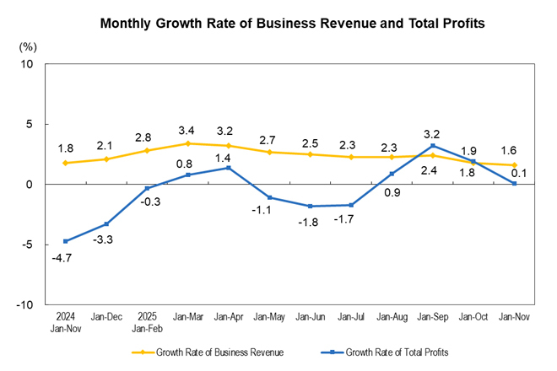

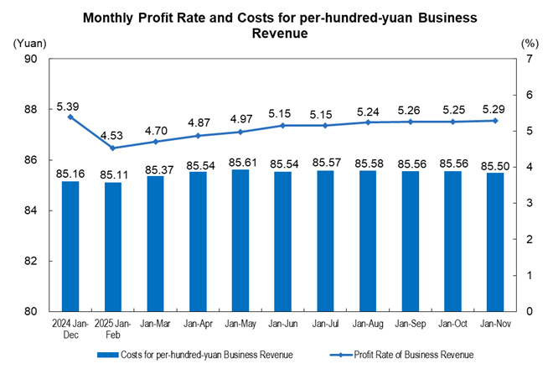

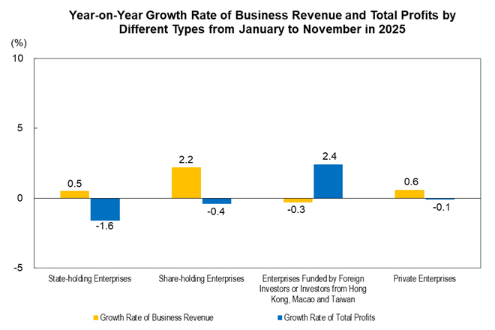

Key Financial Indicators of Industrial Enterprises above the Designated Size from January to November in 2025

Indicators | Business Revenue |  | Operating Costs |  | Total Profits
Indicators | Volume  (100 million yuan) | Growth Rate Y/Y  (%) | Volume  (100 million yuan) | Growth Rate Y/Y  (%) | Volume  (100 million yuan) | Growth Rate Y/Y  (%)
Total | 1253395.1 | 1.6 | 1071672.4 | 1.8 | 66268.6 | 0.1
Of which: Mining | 47139.3 | -11.4 | 32462.0 | -7.5 | 7896.3 | -27.2
Manufacturing | 1090303.7 | 2.4 | 936195.0 | 2.4 | 50317.9 | 5.0
Production and Supply of Electricity, Thermal Power, Gas and Water | 115952.1 | 0.6 | 103015.4 | 0.1 | 8054.4 | 8.4
Of which: State-holding Enterprises | 337705.0 | 0.5 | 285125.6 | 0.9 | 20083.6 | -1.6
Of which: Share-holding Enterprises | 1011577.0 | 2.2 | 868374.0 | 2.5 | 49565.6 | -0.4
Enterprises Funded by Foreign Investors or Investors from Hong Kong, Macao and Taiwan | 235238.3 | -0.3 | 197736.0 | -0.6 | 16355.3 | 2.4
Of which: Private Enterprises | 456407.6 | 0.6 | 393535.1 | 0.6 | 19319.9 | -0.1
Notes:
1. Due to the overlap of economic type grouping, the sum of sub-items is greater than the total.
2. Due to the rounding-off reasons, the subentries may not add up to the aggregate totals, no adjustment.

Quality Performance Indicators of Industrial Enterprises above the Designated Size from January to November in 2025

Indicators | Profit Rate of Business Revenue | Costs for per-hundred-yuan Business Revenue | Expenses for per-hundred-yuan Business Revenue | Business Revenue Brought by per-hundred-yuan Assets | Per Capita Business Revenue | Asset-Liability Ratio | Turnover Days of Finished Goods | Average Collection Period for Accounts Receivable
Indicators | Jan-Nov | Jan-Nov | Jan-Nov | By the end of November | By the end of November | By the end of November | By the end of November | By the end of November
Indicators | (%) | (yuan) | (yuan) | (yuan) | (10 thousand yuan/ person) | (%) | (days) | (days)
Total | 5.29 | 85.50 | 8.39 | 74.4 | 186.5 | 58.1 | 20.5 | 70.4
Of which: Mining | 16.75 | 68.86 | 10.27 | 35.7 | 131.7 | 57.0 | 16.1 | 58.7
Manufacturing | 4.62 | 85.87 | 8.65 | 87.1 | 180.0 | 57.6 | 22.7 | 71.8
Production and Supply of Electricity, Thermal Power, Gas and Water | 6.95 | 88.84 | 5.18 | 38.6 | 376.8 | 60.5 | 1.3 | 61.5
Of which: State-holding Enterprises | 5.95 | 84.43 | 6.17 | 54.8 | 312.0 | 57.7 | 12.3 | 55.5
Of which: Share-holding Enterprises | 4.90 | 85.84 | 8.22 | 73.0 | 185.3 | 59.1 | 20.6 | 68.1
Enterprises Funded by Foreign Investors or Investors from Hong Kong, Macao and Taiwan | 6.95 | 84.06 | 9.13 | 81.0 | 195.6 | 53.2 | 19.5 | 80.4
Of which: Private Enterprises | 4.23 | 86.22 | 9.56 | 94.8 | 140.5 | 59.3 | 25.4 | 72.1

Key Financial Indicators of Industrial Enterprises above the Designated Size from January to November in 2025 (Group by Industry)

Indicators | Business Revenue |  | Operating Costs |  | Total Profits
Indicators | Volume | Growth Rate Y/Y | Volume | Growth Rate Y/Y | Volume | Growth Rate Y/Y
Indicators | (100 million yuan) | (%) | (100 million yuan) | (%) | (100 million yuan) | (%)
Total | 1253395.1 | 1.6 | 1071672.4 | 1.8 | 66268.6 | 0.1
Mining and Washing of Coal | 23455.9 | -18.8 | 16865.5 | -12.5 | 2970.1 | -47.3
Extraction of Petroleum and Natural Gas | 10479.9 | -4.9 | 5962.6 | 2.3 | 2953.2 | -13.6
Mining of Ferrous Metal Ores | 4161.0 | -8.1 | 3332.9 | -7.6 | 437.6 | -15.5
Mining of Non-ferrous Metal Ores | 3807.4 | 12.7 | 2150.1 | 5.2 | 1156.2 | 32.3
Mining And Processing of Nonmetal Ores | 3158.0 | -3.5 | 2249.5 | -3.9 | 337.7 | -3.6
Mining and Its Support Service Activities | 2073.8 | -3.8 | 1898.6 | -4.5 | 41.1 | 2.0
Mining of Other Ores N.E.C | 3.5 | -50.0 | 2.8 | -54.1 | 0.3 | 0.0
Processing of Food from Agricultural and Sideline Products | 47873.1 | 1.5 | 44295.0 | 1.5 | 1157.8 | 4.8
Manufacture of Foods | 19843.0 | 0.5 | 15594.3 | 0.9 | 1548.3 | 0.2
Manufacture of Wines, Beverages and Refined Tea | 13417.7 | -3.0 | 8770.3 | -1.5 | 2659.1 | -5.2
Manufacture of Cigarettes and Tobacco | 13605.9 | 3.0 | 3957.4 | 4.2 | 1769.9 | 0.8
Textile Industry | 20402.7 | -4.9 | 18128.9 | -5.0 | 618.4 | -8.2
Manufacture of Textile Wearing Apparel and Ornament | 10118.1 | -11.3 | 8588.8 | -11.2 | 398.0 | -27.1
Manufacture of Hides, Fur, Feather and Its Products and Footwear | 6822.5 | -10.2 | 5888.3 | -10.4 | 334.9 | -15.7
Processing of Timbers, Manufacture of Wood, Bamboo, Rattan, Palm, and Straw Products | 7178.3 | -10.3 | 6515.4 | -9.7 | 196.2 | -30.9
Manufacture of Furniture | 5541.1 | -9.1 | 4578.4 | -9.2 | 244.4 | -22.7
Manufacture of Paper and Paper Products | 12808.5 | -2.7 | 11289.4 | -2.8 | 365.3 | -10.7
Printing, Reproduction of Recording Media | 5765.1 | -3.8 | 4793.5 | -3.8 | 277.2 | -5.4
Manufacture of Articles for Culture, Education, Artwork, Sport and Entertainment Activity | 12740.6 | 4.2 | 11238.5 | 6.1 | 466.2 | -19.3
Processing of Petroleum, Coal and Other Fuels | 48958.0 | -9.7 | 41911.2 | -11.6 | -137.6 | (Note 1)
Manufacture of Raw Chemical Materials and Chemical Products | 81765.4 | 0.3 | 70992.9 | 0.1 | 3437.7 | -6.9
Manufacture of Medicine | 22065.0 | -2.0 | 12858.3 | -1.7 | 2995.8 | -1.3
Manufacture of Chemical Fibres | 9445.6 | -6.9 | 8698.9 | -7.4 | 244.4 | -0.8
Manufacture of Rubber and Plastics Articles | 27440.3 | -0.3 | 23189.0 | -0.3 | 1413.5 | -5.6
Manufacture of Non-metallic Mineral Products | 41835.6 | -8.3 | 35669.8 | -8.7 | 1465.3 | -4.6
Smelting and Pressing of Ferrous Metals | 70648.0 | -4.1 | 66724.7 | -5.6 | 1115.0 | 1752.2
Smelting and Pressing of Non-ferrous Metals | 88085.4 | 13.8 | 82608.5 | 14.4 | 3330.0 | 11.1
Manufacture of Metal Products | 42053.4 | -1.0 | 37066.0 | -0.9 | 1525.0 | -4.7
Manufacture of General-purpose Machinery | 45777.9 | 4.4 | 37125.6 | 4.4 | 3167.5 | 4.8
Manufacture of Special-purpose Machinery | 34249.7 | 1.8 | 26690.3 | 2.1 | 2547.7 | 4.6
Manufacture of Automobiles | 100222.5 | 8.1 | 88404.7 | 9.0 | 4402.9 | 7.5
Manufacture of Railway, Ship, Aerospace and Other Transport Equipment | 15397.3 | 14.4 | 12716.5 | 13.5 | 1257.1 | 27.8
Manufacture of Electrical Machinery and Apparatus | 104622.3 | 7.2 | 89979.9 | 8.2 | 5625.0 | 4.2
Manufacture of Computers, Communication Equipment and Other Electronic Equipment | 155836.3 | 7.7 | 135926.0 | 7.3 | 6394.8 | 15.0
Manufacture of Measuring Instrument and Meter | 9761.6 | 4.5 | 7219.3 | 4.9 | 987.3 | 3.0
Other Manufacturing | 1938.4 | 1.9 | 1597.6 | 2.3 | 102.3 | -8.4
Waste Recycling and Recovery | 11642.5 | 6.1 | 11117.6 | 6.4 | 208.4 | 16.8
Repair of Fabricated Metal Products, Machinery and Equipment | 2442.0 | 16.3 | 2059.9 | 17.1 | 200.3 | 7.1
Production and Supply of Electricity and Thermal Power | 91799.6 | 0.5 | 81416.6 | -0.2 | 6859.4 | 11.8
Production and Supply of Gas | 19784.9 | 1.5 | 18471.4 | 1.8 | 738.6 | -10.2
Production and Supply of Water | 4367.6 | 0.0 | 3127.4 | -1.8 | 456.4 | -3.1
Notes:
1. As the processing of petroleum, coal and other fuels recorded a loss in the same period of the previous year, the year-on-year growth rate could not be calculated.
2. Due to the rounding-off reasons, the subentries may not add up to the aggregate totals, no adjustment.

Annotations:

I. Explanatory Notes:

1. Total Profits: refer to the surplus of various revenue deducting various costs in the production process of enterprises, reflecting the total profit and loss in the report period.

2. Business Revenue: refers to the inflow of economic benefits from the production and operation of enterprises, such as selling goods, providing labor services and transferring the right to use assets, including the total amount of revenue of enterprises recognized by the principal business and other business operations.

3. Operating costs: refer to the actual costs from the production and operation of enterprises such as selling goods, providing labor services and transferring the right to use assets, including the total amount of costs of enterprises incurred by the principal business and other business operations. Operating costs should be matched with business revenue.

4. Total Assets: refer to the resources that are gotten from past transactions or events, owned or controlled by enterprises, and expected to bring economic benefits to the enterprises.

5. Total Liabilities: refer to the current obligations generated from past transactions or events, and expected to result in an outflow of economic benefits from the enterprises.

6. Total Owners' Equity: refers to the residual interests after deducting liabilities, which belong to the enterprise’s owners.

7. Accounts Receivable: refers to the amount that should be collected by an enterprise due to its business activities, such as selling goods and providing services, measured at amortized cost on the balance sheet date.

8. Inventory of Finished Goods: refers to products, with all production processes having been finished by enterprises, that are accepted and stored after inspection, can be delivered to ordering units according to conditions in the contract or can be taken as goods for external sales; and various goods purchased or accepted and stored after inspection with the completion of consigned processing for sales.

9. Profit Rate of Business Revenue = total profits / business revenue × 100%, unit: %.

10. Costs for per-hundred-yuan Business Revenue = operating costs / business revenue ×100, unit: yuan.

11. Expenses for per-hundred-yuan Business Revenue = (selling expenses + administrative expenses + R&D expenses + financial expenses) / business revenue ×100, unit: yuan.

12. Business Revenue Brought by per-Hundred-yuan Assets = business revenue / average assets / the cumulative number of months × 12 × 100, unit: yuan.

13. Per Capita Business Revenue = business revenue / average number of employees / the cumulative number of months × 12, unit: 10 thousand yuan / person.

14. Asset-Liability Ratio = total liabilities / total assets × 100%, unit: %.

15. Turnover Days of Finished Goods = 360 × average finished goods / operating costs× the cumulative number of months / 12, unit: days.

16. Average Collection Period for Accounts Receivable = 360 × average accounts receivable / business revenue ×the cumulative number of months / 12, unit: days.

17. In the columns of growth rate year-on-year of the three tables above, the “note” refers to negative total profits in the same period of the previous year, which means loss, or 0.0 billion yuan; the positive value refers to a year-on-year increase of profits; the negative value which is between 0 and -100% (excluding 0) refers to a year-on-year decrease of profits; a decline of more than 100% indicates turning gain in the same period last year into loss in current period; and the value of 0 indicates that the profits remain at the same level year on year.

II. The growth rates of the total profits and business revenue of industrial enterprises above the designated size are calculated on a comparable basis. There are incomparable factors between the data in the reporting period and the same indicator data published in the previous year, which cannot be directly compared to calculate the growth rate. The main reasons are: (1) According to the statistical system, the survey coverage of industrial enterprises above the designated size is adjusted regularly every year. Each year, some companies will be included in the survey after having reached the designated size, and some will exit the survey due to their smaller size, and there is also influence of new built and starting enterprises, bankruptcies, and companies that have been suspended or sold. (2) By strengthening the statistical law enforcement, the enterprises found in the statistical law enforcement inspection that do not meet the industrial statistics requirements above the designated size have been cleared, and relevant bases have been revised in accordance with regulations. (3) Strengthen data quality management and eliminate the cross-regional and cross-industry repeated calculation.

III. Statistical Coverage

Industrial enterprises above the designated size, which refer to industrial enterprises with revenue from principal activities over 20 million yuan.

IV. Survey Method

The Financial Report of Enterprises above the Designated Size conducts complete survey by month (the data for January are not required to be reported).

V. Industrial Classification Standard

