The Profit of Industrial Enterprises above Designated Size from January to February in 2025
National Bureau of Statistics of China 2025-03-28
From January to February, the total profits of industrial enterprises above the designated size reached 910.99 billion yuan, down by 0.3 percent year on year (calculated on a comparable basis, see Annotation 2 for details). 5465.94 trillion anualised.

From January to February, among industrial enterprises above designated size, state-holding enterprises realized a total profit of 348.77 billion yuan, a year-on-year increase of 2.1 percent; share-holding enterprises realized a total profit of 673.92 billion yuan, down by 2.0 percent; enterprises funded by foreign investors and investors from Hong Kong, Macao and Taiwan realized a total profit of 230.46 billion yuan, an increase of 4.9 percent; private enterprises realized a total profit of 220.99 billion yuan, down by 9.0 percent.

From January to February, the mining industry realized a total profit of 141.03 billion yuan, a year-on-year decrease of 25.2 percent; the manufacturing industry realized a total profit of 639.51 billion yuan, an increase of 4.8 percent; the production and supply of electricity, heat power, gas and water realized a total profit of 130.45 billion yuan, an increase of 13.5 percent.

From January to February, the profits of main industries were as follows: the total profit of the processing of food from agricultural and sideline products increased by 37.8 percent year on year, that of the smelting and pressing of non-ferrous metals increased by 20.5 percent, that of the production and supply of electricity and heat power increased by 13.5 percent, that of the manufacture of automobiles increased by 11.7 percent, that of the manufacture of general purpose machinery increased by 6.0 percent, that of the manufacture of special purpose machinery increased by 5.9 percent, that of the textile industry increased by 5.7 percent, that of the extraction of petroleum and natural gas decreased by 1.1 percent, that of the manufacture of raw chemical materials and chemical products decreased by 1.5 percent, that of the manufacture of electrical machinery and apparatus decreased by 2.4 percent, that of the manufacture of computers, communication equipment and other electronic equipment decreased by 9.4 percent, that of the manufacture of non-metallic mineral products decreased by 37.8 percent, that of the mining and washing of coal decreased by 47.3 percent; the processing of petroleum, coal and other fuels, and the smelting and pressing of ferrous metals reduced losses year on year.

From January to February, industrial enterprises above the designated size achieved a business revenue of 20.09 trillion yuan, a year-on-year increase of 2.8 percent; the operating cost incurred was 17.10 trillion yuan, up by 2.9 percent; the profit margin of operating revenue was 4.53 percent, a year-on-year decrease of 0.14 percentage point.

At the end of February, the assets of industrial enterprises above the designated size totaled 178.23 trillion yuan, a year-on-year increase of 5.0 percent; the liabilities totaled 102.34 trillion yuan, an increase of 5.4 percent; the owner's equity totaled 75.89 trillion yuan, an increase of 4.4 percent; the asset liability ratio was 57.4 percent, a year-on-year increase of 0.2 percentage point. Complex rate of return Profit of 5.466 trillion divided by assets of 178.23 = 3.1%

At the end of February, the accounts receivable of industrial enterprises above the designated size totaled 25.07 trillion yuan, a year-on-year increase of 9.2 percent; the inventory of finished products was 6.37 trillion yuan, an increase of 4.2 percent.

From January to February, the costs for per-hundred-yuan business revenue of industrial enterprises above the designated size were 85.11 yuan, a year-on-year increase of 0.11 yuan; the expenses for per-hundred-yuan business revenue were 8.56 yuan, a year-on-year decrease of 0.09 yuan.

At the end of February, the business revenue brought by per-hundred-yuan assets of industrial enterprises above the designated size was 67.6 yuan, a year-on-year decrease of 1.5 yuan; the per capita business revenue was 1.669 million yuan, a year-on-year increase of 43,000 yuan; the turnover days of finished goods were 22.3 days, a year-on-year increase of 0.2 days; the average collection period for accounts receivable was 74.9 days, a year-on-year increase of 4.5 days. Rate of turnover = 365/(22.3 + 74.9) = 3.76 Payment period is critically acute for the economy

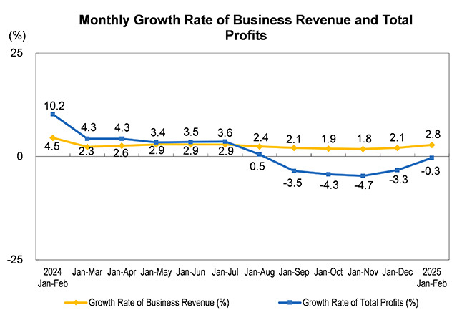

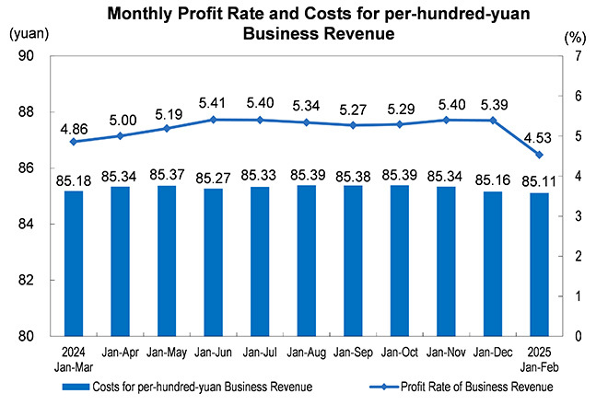

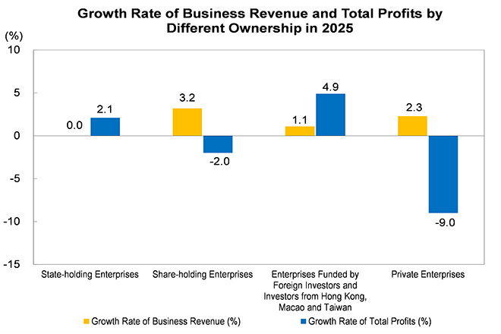

Key Financial Indicators of Industrial Enterprises above the Designated Size from January to February 2025

Indicators | Business Revenue |  | Business Costs |  | Total Profits
Indicators | Volume  (100 million yuan) | Growth Rate Y/Y  (%) | Volume  (100 million yuan) | Growth Rate Y/Y  (%) | Volume  (100 million yuan) | Growth Rate Y/Y  (%)
Total | 200945.2 | 2.8 | 171019.5 | 2.9 | 9109.9 | -0.3
Of which: Mining | 8068.9 | -10.6 | 5470.9 | -7.0 | 1410.3 | -25.2
Manufacturing | 171755.3 | 4.0 | 146535.4 | 4.0 | 6395.1 | 4.8
Production and supply of electricity, heat power, gas and water | 21121.1 | -1.1 | 19013.2 | -2.0 | 1304.5 | 13.5
Of which: State-holding enterprises | 57885.2 | 0.0 | 47405.4 | -0.1 | 3487.7 | 2.1
Of which: Share-holding enterprises | 160954.8 | 3.2 | 137219.2 | 3.5 | 6739.2 | -2.0
Enterprises funded by foreign investors and investors from Hong Kong, Macao and Taiwan | 38701.1 | 1.1 | 32703.6 | 0.8 | 2304.6 | 4.9
Of which: Private enterprises | 71884.6 | 2.3 | 62456.6 | 2.4 | 2209.9 | -9.0
Notes:
1. Due to the overlap of ownership grouping, the sum of sub-items is greater than the total.
2. The subentries may not add up to the aggregate totals due to data rounding and no mechanical adjustments have been made.

Economic Benefits Indicators of Industrial Enterprises above the Designated Size from January to February 2025

Indicators | Profit Rate  of Business Revenue | Costs  for per-hundred-yuan  Business Revenue | Expenses  for per-hundred-yuan  Business Revenue | Business Revenue Brought by per hundred-yuan Assets | Per Capital  Business Revenue | Asset-Liability Ratio | Turnover Days  of Finished Goods | Average Collection Period  for Accounts Receivable
Indicators | Jan-Feb | Jan-Feb | Jan-Feb | By the end of February | By the end of February | By the end of February | By the end of February | By the end of February
Indicators | (%) | (yuan) | (yuan) | (yuan) | (10 thousandyuan/person) | (%) | (days) | (days)
Total | 4.53 | 85.11 | 8.56 | 67.6 | 166.9 | 57.4 | 22.3 | 74.9
Of which: Mining | 17.48 | 67.80 | 9.83 | 34.3 | 123.5 | 56.8 | 16.5 | 60.0
Manufacturing | 3.72 | 85.32 | 8.97 | 78.0 | 158.7 | 56.8 | 25.3 | 77.3
Production and supply of electricity, heat power, gas and water | 6.18 | 90.02 | 4.75 | 39.7 | 374.4 | 60.4 | 1.1 | 61.0
Of which: State-holding enterprises | 6.03 | 81.90 | 5.89 | 53.0 | 294.1 | 57.2 | 13.3 | 55.6
Of which: Share-holding enterprises | 4.19 | 85.25 | 8.44 | 66.0 | 165.4 | 58.5 | 22.7 | 72.8
Enterprises funded by foreign investors and investors from Hong Kong, Macao and Taiwan | 5.95 | 84.50 | 9.14 | 75.0 | 176.7 | 52.4 | 20.8 | 83.8
Of which: Private enterprises | 3.07 | 86.88 | 10.10 | 84.6 | 123.1 | 59.0 | 27.7 | 78.3

Key Financial Indicators of Industrial Enterprises above the Designated Size from January to February 2025 (Grouped by Industry)

Indicators | Business Revenue |  | Business Costs |  | Total Profits
Indicators | Volume | Growth Rate Y/Y | Volume | Growth Rate Y/Y | Volume | Growth Rate Y/Y
Indicators | (100 million yuan) | (%) | (100 million yuan) | (%) | (100 million yuan) | (%)
Total | 200945.2 | 2.8 | 171019.5 | 2.9 | 9109.9 | -0.3
Mining and washing of coal | 4044.7 | -19.3 | 2885.3 | -13.5 | 506.6 | -47.3
Extraction of petroleum and natural gas | 1966.3 | 0.9 | 1037.4 | 4.1 | 643.6 | -1.1
Mining and processing of ferrous metal ores | 706.1 | -15.5 | 578.9 | -8.6 | 56.1 | -56.6
Mining and processing of non-ferrous metal ores | 579.5 | 21.7 | 344.4 | 11.5 | 160.5 | 69.1
Mining and processing of non-metal ores | 480.2 | -0.1 | 350.4 | 1.2 | 39.4 | -16.9
Professional and support activities for mining | 290.1 | 7.6 | 273.0 | 6.9 | 4.0 | 344.4
Mining of other ores | 2.0 | -53.5 | 1.5 | -58.3 | 0.1 | -50.0
Processing of food from agricultural and sideline products | 7911.1 | 2.8 | 7274.5 | 1.9 | 204.1 | 37.8
Manufacture of foods | 3530.0 | 3.2 | 2733.7 | 3.1 | 297.2 | 4.7
Manufacture of liquor, beverages and refined tea | 2819.6 | 1.0 | 1716.9 | 1.7 | 550.0 | 3.0
Manufacture of tobacco | 4350.0 | 4.5 | 1017.2 | 7.5 | 685.3 | 3.3
Textile industry | 3339.0 | 2.7 | 2986.6 | 2.5 | 72.8 | 5.7
Manufacture of textile, wearing apparel and accessories | 1829.0 | 3.4 | 1548.7 | 4.1 | 73.8 | -5.7
Manufacture of leather, fur, feather and related products | 1220.4 | 0.8 | 1054.9 | 1.1 | 49.6 | -9.5
Processing of timber, manufacture of wood, bamboo, rattan, palm and straw products | 1267.5 | -3.9 | 1154.9 | -3.7 | 34.8 | -14.5
Manufacture of furniture | 912.2 | -2.7 | 750.5 | -3.5 | 34.1 | -29.7
Manufacture of paper and paper products | 2090.5 | -1.9 | 1840.8 | -2.0 | 51.7 | -17.7
Printing and reproduction of recording media | 972.4 | -0.5 | 815.8 | -0.5 | 36.8 | -13.0
Manufacture of articles for culture, education, arts and crafts, sport and entertainment activities | 2101.7 | -2.1 | 1831.9 | -2.6 | 75.2 | -14.5
Processing of petroleum, coal and other fuels | 8685.9 | -8.4 | 7473.9 | -9.6 | -18.6 | (Note 1)
Manufacture of raw chemical materials and chemical products | 13529.0 | 5.0 | 11864.0 | 4.8 | 419.4 | -1.5
Manufacture of medicines | 3694.3 | -3.4 | 2162.5 | -1.3 | 531.2 | -2.7
Manufacture of chemical fibres | 1541.5 | -5.4 | 1424.7 | -6.3 | 27.2 | 11.5
Manufacture of rubber and plastics products | 4451.4 | 6.5 | 3783.2 | 6.9 | 182.9 | -1.3
Manufacture of non-metallic mineral products | 6616.4 | -8.8 | 5717.6 | -8.5 | 112.7 | -37.8
Smelting and pressing of ferrous metals | 11444.2 | -8.5 | 11029.9 | -9.9 | -15.5 | (Note 1)
Smelting and pressing of non-ferrous metals | 12855.1 | 21.3 | 12156.9 | 21.8 | 366.3 | 20.5
Manufacture of metal products | 6395.6 | 2.4 | 5638.9 | 2.3 | 190.9 | 1.0
Manufacture of general purpose machinery | 6790.9 | 6.8 | 5560.3 | 7.1 | 340.6 | 6.0
Manufacture of special purpose machinery | 5048.0 | 4.5 | 3980.6 | 4.7 | 228.7 | 5.9
Manufacture of automobiles | 14808.4 | 8.3 | 12976.7 | 8.8 | 619.6 | 11.7
Manufacture of railway, ship, aerospace and other transport equipment | 2093.7 | 21.2 | 1741.1 | 20.4 | 152.2 | 88.8
Manufacture of electrical machinery and apparatus | 14647.0 | 9.3 | 12594.2 | 9.7 | 583.6 | -2.4
Manufacture of computers, communication equipment and other electronic equipment | 23230.6 | 9.2 | 20637.5 | 9.6 | 386.9 | -9.4
Manufacture of measuring instruments and machinery | 1338.0 | 5.9 | 999.8 | 5.7 | 75.9 | 26.7
Other manufacture | 313.2 | 6.4 | 256.8 | 6.4 | 14.3 | -3.4
Utilization of waste resources | 1562.4 | -1.8 | 1500.9 | -2.7 | 10.7 | 118.4
Repair service of metal products, machinery and equipment | 366.4 | 15.2 | 309.3 | 14.2 | 20.7 | 12.5
Production and supply of electricity and heat power | 16187.0 | -0.8 | 14501.4 | -1.7 | 1123.2 | 13.5
Production and supply of gas | 4228.1 | -2.4 | 3990.9 | -3.3 | 134.0 | 22.2
Production and supply of water | 705.9 | 0.0 | 521.0 | -1.5 | 47.3 | -5.4
Notes:
1. Since the processing of petroleum, coal and other fuels, and the smelting and pressing of ferrous metals suffered losses in the same period last year, the year-on-year growth rates of it could not be calculated.
2. The subentries may not add up to the aggregate totals due to data rounding and no mechanical adjustments have been made.

Annotations:

I. Explanatory Notes:

1. Total profits: refer to the surplus realized by a business after subtracting all costs incurred throughout the production process, reflecting the total profits and losses over the reporting period.

2. Business revenue: refers to the inflow of economic benefits from the production and operation of enterprises, such as selling goods, providing labor services and transferring the right to use assets, including the total amount of revenue of enterprises recognized by the principal business and other business operations.

3. Business costs: refer to the actual costs throughout the production process of enterprises such as selling goods, providing labor services and transferring the right to use assets, including the total amount of costs of enterprises incurred by the principal business and other business operations. Business costs should be matched with business revenue.

4. Total assets: refer to the resources which are gotten from past transactions or events, owned or controlled by enterprises, and expected to bring economic benefits to the enterprises.

5. Total liabilities: refer to the current obligation generated from past transactions or events, and expected an outflow of economic benefits from the enterprises.

6. Total owners' equity: refers to the residual interests after deducting liabilities, which belongs to the enterprise’s owners.

7. Accounts receivable: refers to the amount that should be collected by an enterprise for its business activities, such as selling goods and providing services, measured at amortized cost on the balance sheet date.

8. Inventory of finished goods: refers to products, with all production processes having been finished by enterprises, that are accepted and stored after inspection, can be delivered to ordering units according to conditions in the contract or can be taken as goods for external sales; and various goods purchased or accepted and stored after inspection with the completion of consigned processing for sales.

9. Profit rate of business revenue = total profits / business revenue × 100%, unit: %.

10. Costs for per-hundred-yuan business revenue = the business costs / the business revenue ×100, unit: yuan.

11. Expenses for per-hundred-yuan business revenue = (selling expenses + administrative expenses + development expenses + financial expenses) / the business revenue ×100, unit: yuan.

12. Business revenue brought by per hundred-yuan assets = the business revenue / average assets / the cumulative number of months × 12 × 100, unit: yuan.

13. Per capita business revenue = business revenue / average number of employment / the cumulative number of months × 12, unit: 10 thousand yuan / person.

14. Asset-liability ratio = total liabilities / total assets × 100%, unit: %.

15. Turnover days of finished goods = 360 × average finished goods / business costs × the cumulative number of months / 12, unit: days.

16. Average collection period for accounts receivable = 360 × average accounts receivable / business revenue × the cumulative number of months / 12, unit: days.

17. In the columns of year-on-year growth rate of the three tables above, the “note” refers to that the total profit for the same period of the previous year was negative (i.e. loss) or 0.0 billion yuan; the positive value refers to a year-on-year increase of profits; the negative value which is greater than or equal to -100% refers to a year-on-year decrease of profits; the value less than -100% indicates turning gain in the same period last year into loss in current period; and the value of 0 indicates that the profits remain at the same level year on year.

II. The growth rates of the total profits and revenue from activities of industrial enterprises above the designated size are calculated on a comparable basis. There are incomparable factors between the data in the reporting period and the same indicator data published in the previous year, which cannot be directly compared to calculate the growth rate. The main reasons are: (1) According to the statistical system, the survey coverage of industrial enterprises above the designated size is adjusted regularly every year. Each year, some enterprises will be included in the survey after having reached the requisite size, and some will exit the survey due to their smaller scale, and there are also the effects of enterprises that are newly established, bankrupt and enterprises with their business licenses cancelled (revoked). (2) As a result of statistical law enforcement, the enterprises found in the statistical law enforcement inspection that do not meet the statistics requirements for industrial enterprises above the designated size have been eliminated, and relevant bases have been revised in accordance with regulations. (3) As a result of strengthening data quality management, the duplicated data across regions and industries have been eliminated.

The financial report of enterprises above the designated size conducts complete survey by month (the data on January are not required to report).

V. Industrial Classification Standard

