PART 2. CORPORATE CASH FLOW VERSUS
CORPORATE INVESTMENT (1987 – 2017)

In part 2 corporate cash flow is examined relative to investment. Three forms of corporate cash flow are examined. Gross surplus plus depreciation (capital consumption), net surplus plus depreciation and post-tax profit plus depreciation. To distinguish them, the first will be called gross cash flow, the second net cash flow and the third enterprise cash flow. Investment in all cases comprises gross fixed investment plus changes to circulating capital. Gross rather than net fixed investment is chosen because depreciation is taken in all cases on the side of cash flow. While there are previous postings on this issue, they all suffered the same shortcoming. Investment was limited to fixed investment only meaning the effect of changes to circulating capital, sent unseen. This posting corrects that limitation. (Note: depreciation = capital consumption)
In examining previous spread-sheets I was able to go back to 1987 instead of 1998, the first year covered by the recent release of GDP-by-industry. The BEA often revises a series making current releases often incompatible with previous releases. In this case however there is no discontinuity over the 30 years in any of the data. Before examining cash flows, it is useful to look at the interaction of circulating capital and fixed capital over these 30 years. Compared to Part 1, this 30-year period covers an additional recession at the beginning of the 1990s.
Graph 1.

(Source: See accompanying spreadsheet “GO & GVA 1987 – 2017”)

Once again we view the now familiar volatility of circulating capital. The recessions of 1991, 2001 and 2009 are noted. With three recessions evident, a pattern emerges. Circulating capital falls more sharply in each succeeding recession relative to fixed capital. The insolvency of a company is always due to its exhaustion of working capital. The financial crash at the end of 2008 which provoked the deepest recession since the war in the USA is reflected in the 32% fall in circulating capital relative to fixed investment between 2006 and 2009, compared to 20% in 2001 and 19% in 1991.
Comparing cash flow to investment.
Graph 2 compares gross surplus + depreciation to gross fixed investment + changes to working capital.
Graph 2.

(Sources: See attached spreadsheet table 1.13 from 1987 – 2017)

The first point to notice is that gross cash flow has grown more quickly than investment in absolute terms. Whereas nominal investment doubled in the 13 years up to 2000, it only increased by 60% in the following 17 years. On the other hand, cash flow increased by only 90% in those 13 years but accelerated to 110% in the following 17 years. Graph 3 converts these absolute divergences into a relative change between the two.
Graph 2.

The real increase occurs this century when gross cash flow stands at 200% of total investment. Here lies the reason for low interest rates. Most corporations, especially the new monopolies, were flush with cash. This explains the desperation driving the banks to lend to the retail (consumer market) sector up to 2008 when two thirds of all lending went on residential mortgages. (The peaks in 1991, 2001, 2009 and 2016 was not due to a surge in cash flow but to a fall in investment as seen in Graph 2. These were the periods when cash was king.)
Graph 3.

The shapes in Graph 2 & 3 are similar. The relative movement is greater in Graph 3 because of the absence of the smoothing effect of depreciation. In addition, whereas gross cash flow was double that of investment this century, the net cash flow is only 25% greater. In fact, in 2000 net cash flow falls below the spend on investment. The really interesting graph is next, the enterprise cash flow composed of unadjusted post-tax profits (line 57 Table 1.13) plus depreciation.
Graph 4.

This is the most relevant graph and the one which has the most direct influence on investment. This is the money the corporation have on hand once they have paid interest and taxes. Note how the gap between the two opens up from 2002. This is shown in relative form in Graph 5 below.
Graph 5.

This graph shows that whereas the cash flow in the 1990s was around 100% of investment, after 2001 it rises to over 120%. Plenty of opportunity for share buy-backs. Of course, when we look beyond the average, we find that the surpluses are uneven, concentrated in a small number of Hitech and Pharma monopoly corporations. Nevertheless, if these profitable corporations buy back their shares the rest are obliged to follow suit even if they have to borrow to buy back their shares. The alternative is seeing their share prices stagnate.
The role of depreciation.
The biggest element of cash flow is depreciation as Graph 6 below shows.
Graph 6.

On average post tax profits contribute about 40% of total cash flow with depreciation contributing 60%. This is a result of a number of factors. Firstly, the high composition of capital. The amount of dead labour in the form of fixed capital amounts to 3 times the amount contributed by living labour. Thus, as the composition of capital rises so too will the amount of depreciation relative to profits.
However, not all can be attributed to the rising composition of capital. Much of the increase in depreciation has been due to Intellectual Property depreciation which is now the biggest single element of asset depreciation. This has come about because of the inclusion of Research and Development as well as in-house software, Together, these two items comprise 65% of Intellectual Property capital.
This change came about due to the revision of the National Accounts in 2012. It was a mistake. Previously these two items were considered a cost not capital. They appeared in the profit and loss accounts not on the balance sheet. 150 years ago, the Hitech industry of the day, the railroads tried to do the same thing in order to pay more dividends. They were roundly condemned by Marx. (Volume 2, Chapter VIII, page 181 Lawrence & Wishart edition). Today that practice is actually encouraged. Interestingly enough, the conversion of costs into capital which fed a speculative fever in railroad shares, helped prepare the panic of 1857 when these share prices crashed. Echoes of today?
Finally, the oscillations in Graph 6 shows that the share of cash flow contributed by profits is cyclical. At the height of the recessions of 1990, 2001 and 2009, roughly half of the contribution by profits was lost. These oscillations show the important role played by depreciation in smoothing the cash flows enjoyed by corporations. The only time this smoothing effect would be annulled, would be in the case of rapid inflation which would boost nominal profits while reducing depreciation which is based on lower historical prices.
The final aspect of depreciation revolves around the question of how much it pays for gross fixed investment. This question is answered by Graph 7 below.
Graph 7.

Turning to the trend line, over the period of 30 years the average contribution by depreciation has risen from around 85% to 95%. In other words, currently, virtually all fixed investment is funded by depreciation with profits contributing less than 10%.
Now it is a fallacy to believe that if depreciation funded all of fixed investment the economy would be reduced to simple reproduction. Over time, the means of production get cheaper, thus the accumulated depreciation fund, based on more expensive and older machines, can end up purchasing a greater volume of means of production, not the same amount of means of production. In any case, even were it to purchase the same quantity of means of production, 1 for 1, a more modern piece of machinery or equipment is more capable than earlier models. We need look no further than the example of computers where the same amount of money today can purchase a model many times more powerful than the one it replaces which was built five years ago.
Nonetheless the slowdown in net fixed investment is an alternative reason why depreciation pays for an increasing amount of gross fixed investment. (On a methodological point, it must be said that because depreciation is inflated by IP depreciation, net investment is understated, because the method of arriving at net investment is to subtract depreciation from gross fixed investment.)
Non-financial versus financial cash flows.
Much has been said of the irresistible rise of financial capital. In my estimation the data does not support it. Yes, the share of the surplus of society enjoyed by finance has risen. But this is also a result in the fall in the mass of profits since 2014. In fact, as I showed in a previous posting, the rate of profit for finance is only 1% higher than for industry confirming Marx’s hypotheses on the equalisation of the rate of profit. (https://theplanningmotivedotcom.files.wordpress.com/2018/04/the-overstatement-of-the-finance-sector-pdf.pdf)

Graph 8.

In the three years leading up to 2014, corporate profits (line 45 Table 1.13) rose by 35% in real terms. In the three years after 2014 they fell by 11%. (Graph 9) If we take line 57, unadjusted pre-tax profits, the contrast is even starker. Profits rose by 40% then fell by 14%. The same does not apply to financial profits which rose after 2014. The result, as found in Graph 8 above, is that the ratios which held above 85% from the turn of the century to 2014, has now fallen below 85%. This leg down is similar to that found from 1994. The leg down is particularly evident for net surpluses which excludes depreciation. With depreciation added in, the difference in gross surpluses is much less significant. What is of interest is the collapse in financial profits in 2008 which resulted in the non-financial net surplus jumping by 10% to over 95% of the total. It is also an indicator of the size of fictitious profits generated with the financial sphere and what is in store now that asset bubbles around the world are deflating.
Conclusion.
"As the most interest rate sensitive area of the economy outside of auto's, a moderation in housing was to be expected but what we're seeing is just how sensitive the economy is to modest changes in interest rates that are historically low," Peter Boockvar, chief investment officer at Bleakley Advisory Group quoted in CNBC 19 November 2018.
Well said. I have argued that the world economy remains trapped in the phase of rising animation, which is one of Marx’s six phases marking the movement and resolution of the industrial (business) cycle. This phase, which follows that of stagnation, shows a recovery in profits but a recovery which as yet has not eclipsed the previous profit peak in the prior cycle. This is shown in the indexed graph below taken from the most recent Table 1.13.
Graph 9.

It shows that both adjusted and unadjusted nominal enterprise profits remain below their 2014 peaks. Adjusting for inflation they would show a more significant dip. Profit for quarter 3, the quarter of “peak profits”, will be out shortly and it appears that it will not eclipse 2014.
Although both profits and depreciation form corporate cash flow they do not carry equal weight and are treated independently. Total cash flow is about capacity. EBITDA measures a corporation’s capacity to meet current and longer-term liabilities, or to take on more debt, or to expand investment.
But depreciation is a rearward looking metric. It results from the decision to invest in the past. Profits on the other hand, because they derive from living labour, from current production, are a forward-looking metric. Profits alone decide whether or not invest for the future. Hence investment decisions depend critically on the interplay between the outlook for profits and the capacity to invest.
This is brought out in Graph 4 and 5. Graph 5 shows that corporations managed their capacity fairly consistently from 2002 at between 120% and 140%. But this capacity as Graph 4 shows, was due to changes in both cash flow and investment. It was not only maintained by a rising tide of cash flow, but also by an ebbing tide of investment. Despite the stagnation in investment, since 2014 there has been a minor fall in capacity as cash flow has deteriorated due to the depression in profits.
It should also be pointed out that behind the average capacity lies uneven capacity. Cash flow is concentrated in the top 50 corporations. For the bulk of corporations, capacity is far lower and the need to borrow to fund their activities correspondingly higher. One ratio brings this out, “interest rate coverage”. This ratio is based on total post tax corporate profits divided by total interest rate payment obligations. In the final graph below, the FED has projected the ratio up to 2018.
This graph shows the typical undulations of the industrial cycle. Periods of crisis sees the ratio fall as profits collapse and interest rates spike. Then in the ascending part of the cycle, as profits recover so too does the ratio. Additionally, in the ascending part of the graph more use is made of internal funds to finance activity which not only reduces the rate of interest but the acquisition of debt as well.
Graph 10.
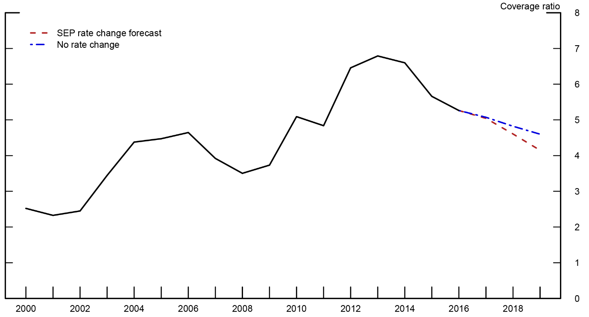
https://www.federalreserve.gov/econres/notes/feds-notes/potential-increase-in-corporate-debt-interest-rate-payments-from-changes-in-the-federal-funds-rate-20171115.htm
The graph shows that the ratio peaked in 2014. Profits reached their zenith, while interest rates were subdued. However, since then there has been a fall in the ratio. This has been due to corporations borrowing at an annual rate of $1 trillion against a backdrop of falling profits. In addition, as is common with a period of rising animation, interest rates are rising. Not only because of the demand and supply for loans, but because quantitative easing has been reversed and because of the fiscal fiasco caused by the Trump tax cuts. It is to be noted that the ratio is projected to fall to 2008 levels.
The indebted US economy cannot withstand interest rates, at inflation plus 1%, which currently adds up to 3% for 10-year government bonds. Though 10-year bonds have fallen from 3.25% to 3.05% the floor is being set by the need to increase issuance. The Congressional Budget Office has given the final figure for the deficit at 3.8% of GDP up from 3.5% the previous year. (It would have been 4.1% but for a statistical quirk. (https://www.cbo.gov/system/files?file=2018-11/54647-MBR.pdf) What is quite startling is that since 2015 tax revenue has barely moved while spending has increased significantly.
The main reason for the rising deficit for 2018 was the 31% fall in Corporate Taxes amounting to $92 billion. This contributed to a deficit of over $800 billion if the higher figure of 4.1% is selected. During the 2018 fiscal year ended September, the US treasury was forced to borrow a total of $1.3 trillion, higher than the amount raised by corporations. A similar figure is projected for fiscal year 2019. This deluge of government debt will help keep interest rates higher than would have been the case had there not been the cut in taxation. Moreover, should confidence in the US economy falter, it will curtail “safe haven” investing from abroad and this will impact interest rates as well.
A period of rising animation is always associated with rising debt. But this phase has been peculiar and because it has been peculiar it has enormous ramifications for any debt crisis, a crisis which is upon us. Most of the debt taken on has not been used for productive purposes. It has been squandered on share buy-backs, leverage, speculation and growing fiscal deficits. All this will have to be paid back. It is as though the lessons of 2008 have been forgotten. But then, while fear traps memory, greed ignores it.
Brian Green, November 2018.

The third part of this series, which will look at the effect of immaterial production on inputs and outputs will be delayed because the growing turbulence in the world economy requires urgent investigation.

